|  |
| --- |
| Circle Language Spec: Commands |

## Command Calls in an Active Clause in a Diagram

This article demonstrates a situation of command objects.

This article illustrates how command calls in an active clause look in a diagram.

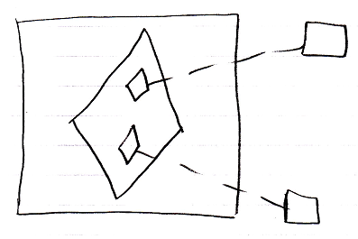

The large square is the command definition the clause is in. The diamond inside of it, is the active clause. It contains two diamonds, which are the command calls inside the active clause. The small diamonds redirect their command definition with a class line, a dashed line, connected to the squares on the right, which are the command definitions, that are called.